**How to Select Option from DropDown using Selenium Webdriver**

In this tutorial, we will learn how to handle Drop Down and Multiple Select Operations.

**Drop-Down Box**

Before we can control drop-down boxes, we must do following two things:

1. Import the package **org.openqa.selenium.support.ui.Select**
2. Instantiate the drop-down box as a "Select" object in WebDriver

As an example, go to Mercury Tours' Registration page (<http://newtours.demoaut.com/mercuryregister.php>) and notice the "Country" drop-down box there.

[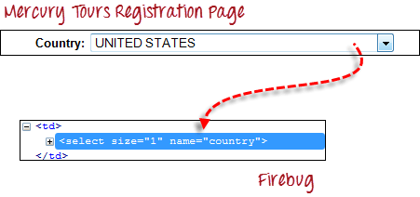](http://cdn.guru99.com/images/image011(3).png)

**Step 1**

Import the "Select" package.

[How to Select Option from DropDown using Selenium Webdriver](http://cdn.guru99.com/images/image012(1).png)

**Step 2**

Declare the drop-down element as an instance of the Select class. In the example below, we named this instance as "drpCountry".

[How to Select Option from DropDown using Selenium Webdriver](http://cdn.guru99.com/images/image013(3).png)

**Step 3**

We can now start controlling "drpCountry" by using any of the available Select methods. The sample code below will select the option "ANTARCTICA."

[How to Select Option from DropDown using Selenium Webdriver](http://cdn.guru99.com/images/image014(3).png)

**Selecting Items in a Multiple SELECT elements**

We can also use the **selectByVisibleText()** method in selecting multiple options in a multi SELECT element. As an example, we will take <http://jsbin.com/osebed/2> as the base URL. It contains a drop-down box that allows multiple selections at a time.

[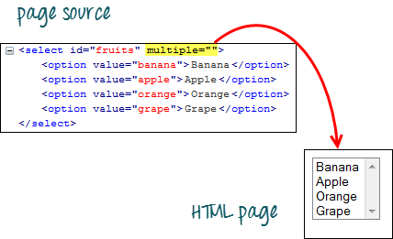](http://cdn.guru99.com/images/image015(3).png)

The code below will select the first two options using the selectByVisibleText() method.

[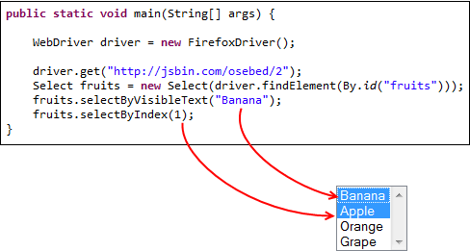](http://cdn.guru99.com/images/image016(3).png)

**Select Methods**

The following are the most common methods used on drop-down elements.

|  |  |
| --- | --- |
| **Method** | **Description** |
| **selectByVisibleText()**and**deselectByVisibleText()** *Example:*[How to Select Option from DropDown using Selenium Webdriver](http://cdn.guru99.com/images/image017(3).png) | * Selects/deselects the option that displays the text matching the parameter. * **Parameter**: The exactly displayed text of a particular option |
| **selectByValue()** and**deselectByValue()** *Example:*[How to Select Option from DropDown using Selenium Webdriver](http://cdn.guru99.com/images/image018(3).png) | * Selects/deselects the option whose "value" attribute matches the specified parameter. * **Parameter**: value of the "value" attribute * Remember that not all drop-down options have the same text and "value", like in the example below.   [How to Select Option from DropDown using Selenium Webdriver](http://cdn.guru99.com/images/image019(2).png) |
| **selectByIndex()** and**deselectByIndex()** *Example:[How to Select Option from DropDown using Selenium Webdriver](http://cdn.guru99.com/images/image020(2).png)* | * Selects/deselects the option at the given index. * **Parameter**: the index of the option to be selected. |
| **isMultiple()** *Example:[How to Select Option from DropDown using Selenium Webdriver](http://cdn.guru99.com/images/image021(2).png)* | * Returns TRUE if the drop-down element allows multiple selections at a time; FALSE if otherwise. * **Needs parameters needed** |
| **deselectAll()** *Example:[How to Select Option from DropDown using Selenium Webdriver](http://cdn.guru99.com/images/image022(2).png)* | * Clears all selected entries. This is only valid when the drop-down element supports multiple selections. * **No parameters needed** |

**Here is the complete code**

package newproject;

import org.openqa.selenium.WebDriver;

import org.openqa.selenium.firefox.FirefoxDriver;

import org.openqa.selenium.support.ui.Select;

public class accessDropDown {

public static void main(String[] args) {

System.setProperty("webdriver.firefox.marionette","C:\\geckodriver.exe");

String baseUrl = "http://newtours.demoaut.com/mercuryregister.php";

WebDriver driver = new FirefoxDriver();

driver.get(baseURL);

Select drpCountry = new Select(driver.findElement(By.name("country")));

drpCountry.selectByVisibletext("ANTARCTICA")

//Selecting Items in a Multiple SELECT elements

driver.get("http://jsbin.com/osebed/2");

Select fruits = new Select(driver.findElement(By.id("fruits")));

fruits.selectByVisibleText("Banana")

fruits.selectByIndex(1);

}

}

**Summary**

|  |  |  |
| --- | --- | --- |
| **Element** | **Command** | **Description** |
| **Drop-Down Box** | *selectByVisibleText()/deselectByVisibleText()* | selects/deselects an option by its displayed text |
| *selectByValue()/deselectByValue()* | selects/deselects an option by the value of its "value" attribute |
| *selectByIndex()/deselectByIndex()* | selects/deselects an option by its index |
| *isMultiple()* | returns TRUE if the drop-down element allows multiple selection at a time; FALSE if otherwise |
| *deselectAll()* | deselects all previously selected options |

To control drop-down boxes, you must first import the org.openqa.selenium.support.ui.Select package and then create a Select instance.